TEXT HISTOGRAM: LAB ASSIGNMENT

# PREPARED BY: **ISHAN GAUTAM**

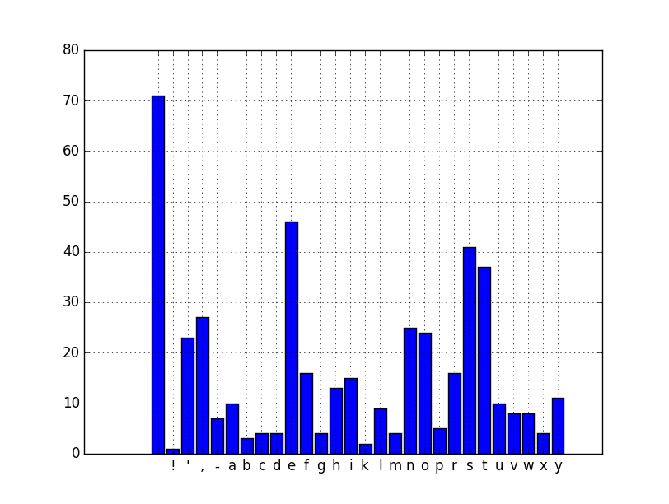

Figure 1 Example histogram

## Readme for the code:

### File Description:

1. ***template.cu*** contains the main program with all the calling codes and CPU codes
2. ***kernels.cu*** contains the GPU kernels
3. ***config.h*** contains the config details for the program to run

* Were there any difficulties you had with completing the optimization correctly?
* File read process
* Number of blocks/threads
* Using shared mem
* Which optimizations gave the most benefit?

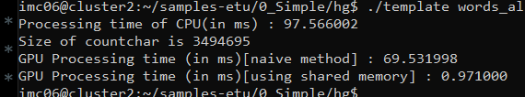

* For the histogram kernel, how many global memory reads are being performed by your kernel? explain.
* For the histogram kernel, how many atomic operations are being performed by your kernel? explain.
* Most text files will consist of only letters, numbers and whitespace characters. What can we say about atomic access contention regarding the number of threads that are simultaneously trying to atomically increment a private histogram?